Radial Calendar Chart

Connect to Sample Superstore Data

Create a parameter Depth with the following Details

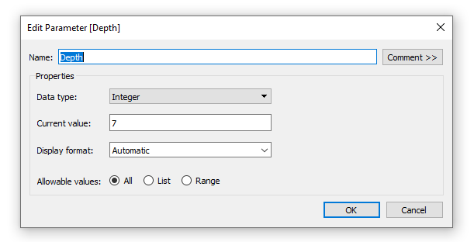

Create another Parameter Distance from the Center with the following Details

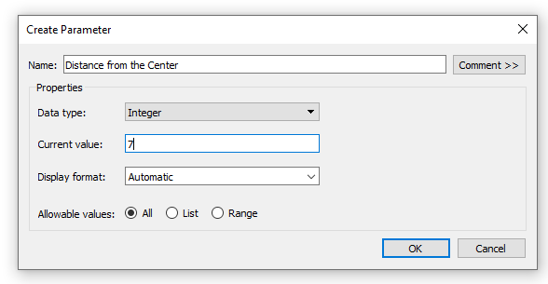

Create a calculated field Index

INDEX()-1

Create a calculated field Multiplier

360/53

Create another calculated Field Item

IF [Index]%[Depth]<[Depth]/2 THEN

ROUND([Index]/[Depth],0)

ELSE

ROUND([Index]/[Depth],0)-1

END\*[Multiplier]

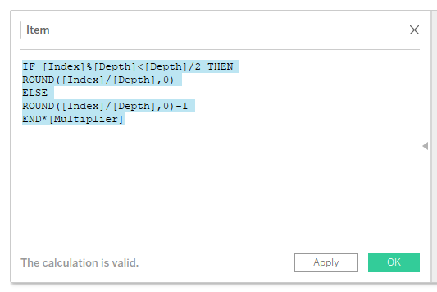

Another calculated Field

Distance

([Index]%[Depth])+[Distance from the Center]

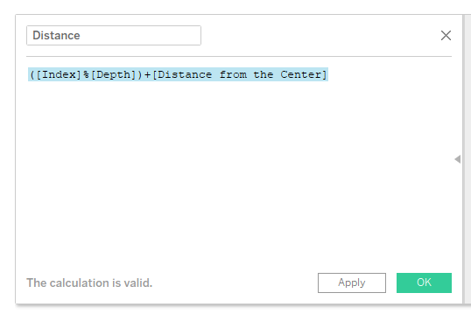

Calculated field

X

SIN(RADIANS([Item]))\*[Distance]

Y

COS(RADIANS([Item]))\*[Distance]

Drag Order Date to the filters and Select 2018

Again Drag Order date to the rows shelf and click years, Click on the drop down on the years on the rows shelf and check exact date , check on discrete and the on show missing values.

Drag the order date dimension from the rows shelf to the details shelf.

Drag the Calculated fields X and Y to the columns and rows shelf respectively and then compute using order date.

Drag Order Date dimensions to the colors marks card and select month.

Click on the shape on the marks card and then select the desired shape.

Format the sheet as desired.

Drag sales, quantity and profit from the measures to the tool tip.